Image Synthesis

Homework 3 – Ray Tracing

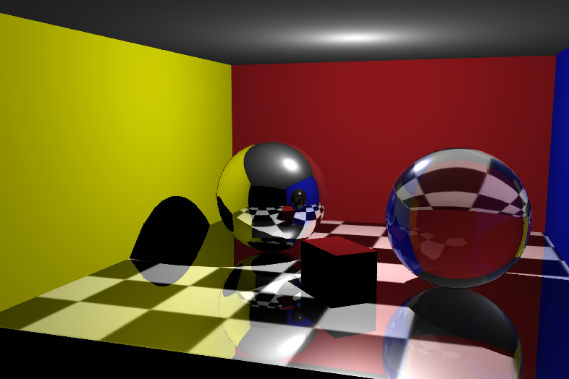

|  |  |
| --- | --- |
| Name | Dima Ogurtsov |
| ID | 326814910 |
| e-mail | ogurdima@gmail.com |

|  |  |
| --- | --- |
| Name | Yacov Glushkin |
| ID | 326814902 |
| e-mail | yacov.gls@gmail.com |

# Introduction

In this homework we implemented a raycasting algorithm that we learned on lecture.

How to use the plugin:

1. Load plugin
2. Create polygonal scene
3. In script editor type a command according to your instructions
   1. Default value is taken if the argument is not passed. The default values are
      1. –w 1920
      2. –h 1080
      3. –n 1
      4. –ss uniform
      5. –sr 1
      6. –misr 1
      7. –masr 128
      8. –t 0.05
   2. Meaning of –sr flag varies depending on supersampling type. In case of adaptive supersampling value of –sr is not taken. In case of uniform or jittered supersampling the value means **samples per dimention**, while for random it means **samples per pixel**. So you can compare uniform 2 with random 4.
   3. –misr and –masr are measured in **samples per pixel.**

# Assumptions

The implementation we provided makes the following assumptions:

1. There is at least one object (mesh) in the scene
2. All geometric objects in scene are meshes
3. There are only three light types used in the scene: ambient, point and directional.
4. If an object has a texture it must be monolith – at most one texture per mesh, only one UV set
5. All textures are of FileTexture type (not built in Maya textures but those that you provide using texture file)
6. There are only two types of material – Lambert and Phong.
7. If a mesh is transparent, it must be water tight manifold.
8. Maya’s reflectivity and transparency attributes are taken while computing energy distribution between refracted and reflected rays. Ambient, diffuse and specular coefficients are treated as usual.
9. All command line arguments have positive integer value

# Important Implementation Details

The plugin creates an iff image called "C:/temp/scene.iff" – a resulting image of the ray tracing

The plugin creates txt file called "C:/temp/stat.txt" – statistics of the latest run

Rendering is done using camera with name “cameraShape1”. If no such camera found – using Maya’s active 3d view. The plugin opens the resulting image in Maya automatically in the end of the run.

# Supersampling methods demonstration

#### No supersampling vs uniform 4 rays per pixel

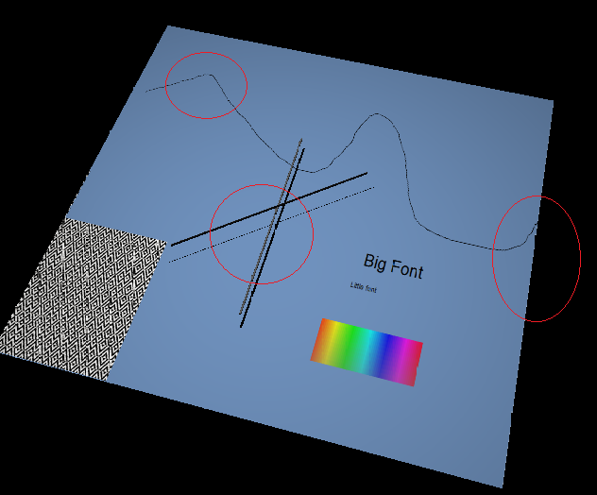

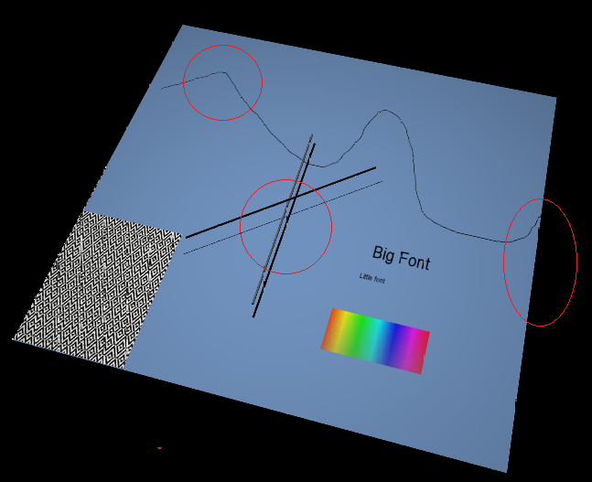

#### Uniform 4 rays per pixel vs jittered 4 rays per pixel



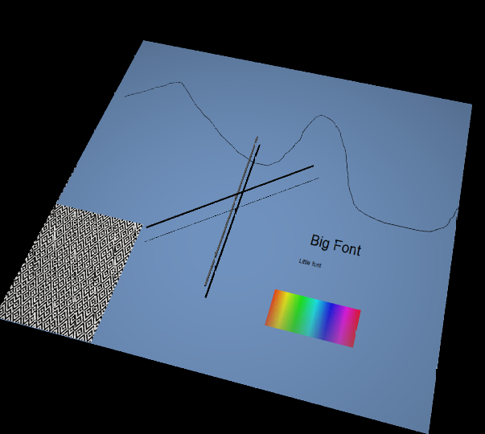

#### Jittered 4 rays per pixel vs random 4 rays per pixel



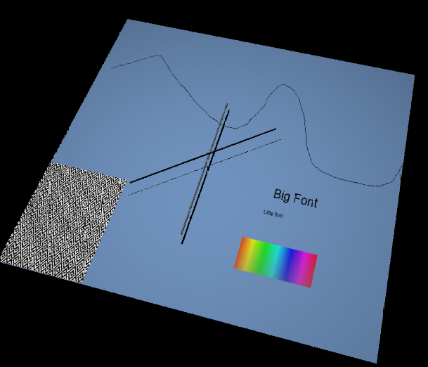

#### Adaptive (max = 16, betha = 10%, tolerance = 0.001, 2.47 samples per pixel in average) vs random 4 rays per pixel

#### 



#### Supersampling methods on the same scene

